

INTRODUCTION TO COMPUTER SYSTEMS (IT1020)

Year 1, Semester 1

Lab sheet 04

22278944, Vikum Chathuranga Basnayaka

Y1.S1.WD.IT.17

24-11-2022

**Activity**

1. Addition (If S = 0)

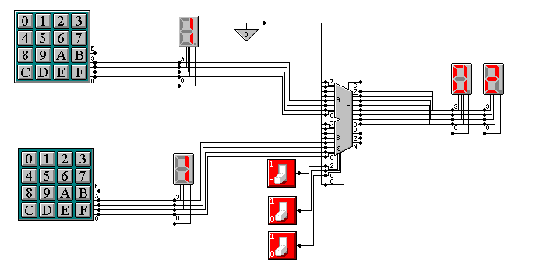

1. Subtraction (If S = 1)

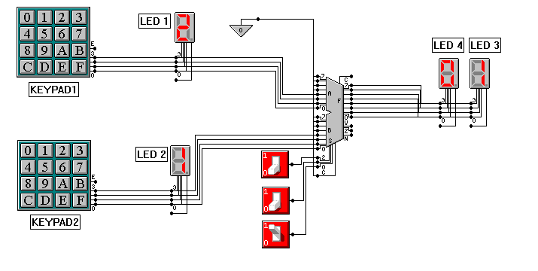

1. Multiplication (If S = 2)

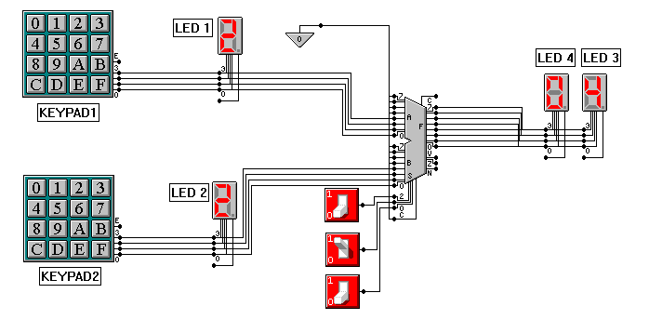

1. Division (If S = 3)

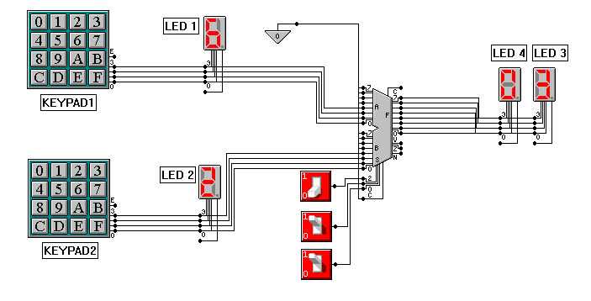

1. Equality (If S = 4)

# Output to F is A = B (output is 0 for False and 1 for True)

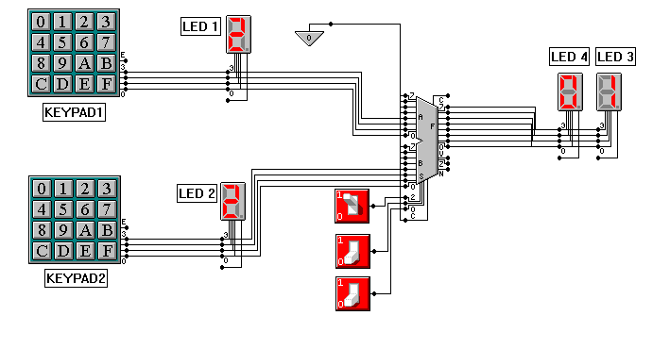

1. Less or Greater sign (IF S = 5)

# Output to F is A < B (output is 0 for False and 1 for True)

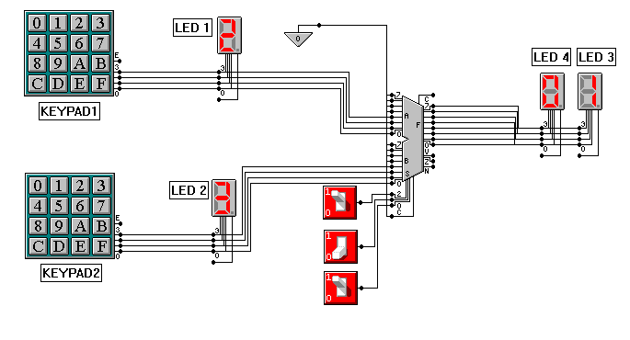

1. Shifting left (If S = 6)

# Output to F is A << B (A left shifted by B) fill with Cin

Cout is the last (upper) bit shifted out of A.

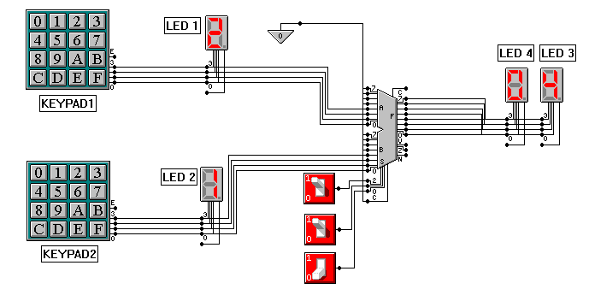

1. Shifting Right (If S = 7)

# Output to F is A >> B (A right shifted by B) fill with Cin

Cout is the last (lower) bit shifted out of A.

